Listing Facts
Now that we can create new facts, we should also have a way to list all our facts. Let’s update the home route and adapt it to ListFacts
1  2  3  4  5  6  7  8  9  10  11  12 | package main  import (  "github.com/gofiber/fiber/v2"  "github.com/divrhino/divrhino-trivia/handlers"  )  func setupRoutes(app *fiber.App) {  app.Get("/", handlers.ListFacts)  app.Post("/fact", handlers.CreateFact)  }
Then let’s also change the home handler to be ListFacts
1  2  3  4  5  6  7  8  9  10  11  12  13  14  15  16  17  18  19  20  21  22  23  24  25  26  27 | package handlers  import (  "github.com/gofiber/fiber/v2"  "github.com/divrhino/divrhino-trivia/database"  "github.com/divrhino/divrhino-trivia/models"  )  func ListFacts(c *fiber.Ctx) error {  facts := []models.Fact{}  database.DB.Db.Find(&facts)  return c.Status(200).JSON(facts)  }  func CreateFact(c *fiber.Ctx) error {  fact := new(models.Fact)  if err := c.BodyParser(fact); err != nil {  return c.Status(fiber.StatusInternalServerError).JSON(fiber.Map{  "message": err.Error(),  })  }  database.DB.Db.Create(&fact)  return c.Status(200).JSON(fact)  }
We can use Insomnia get a list of all our facts. Currently we only have one. Let’s add a few more and get the list with all the new facts.
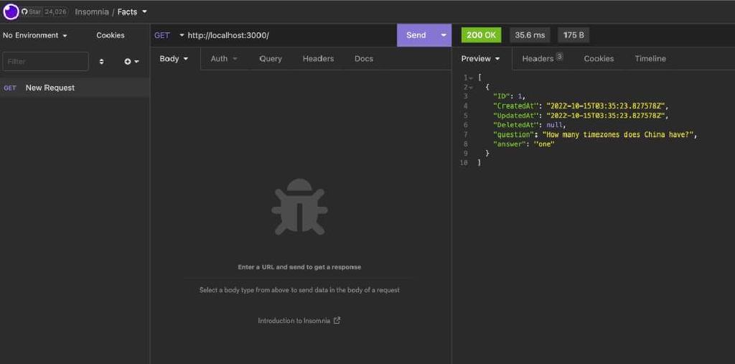

Conclusion
And there you have it. In this tutorial we learnt how to create a simple trivia app from scratch using Go and Docker. We started with a blank folder and worked our way up to creating a multi-container app with a Postgres database. The finished code for this project can be found in the Github repository.
Congratulations, you did great! Keep learning and keep coding. Bye for now,

